Pizza Sales SQL Queries

1. Total Revenue

select

round(sum(total_price),2) as Total_Revenue

from

pizza_sales;

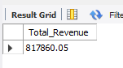

1. Average Order Value

select

round(sum(total_price)/count(distinct order_id),2) as Avg_Order_Value

from

pizza_sales;

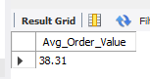

1. Total Pizza Sold

select

sum(quantity)as Total_Pizza_Sold

from

pizza_sales

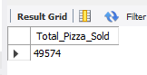

1. Total Order

select

count(distinct order_id) as Total_Order

from

pizza_sales;

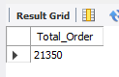

1. Average Pizza Per Order

select

round(sum(quantity)/ count(distinct order_id),2) as Avg_Pizza_Per_Order

from

pizza_sales;

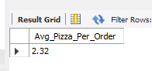

1. Day wise order

select

dayname(order_date),

count(distinct order_id)

from sales

group by dayname(order_date);

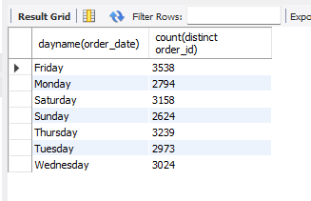

1. Month wise order

select

monthname(order_date),

count(distinct order_id)

from sales

group by monthname(order_date);

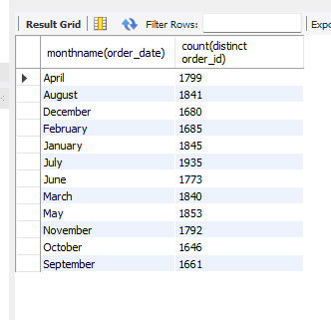

1. Category wide % of total sales

select

distinct pizza_category,

round(sum(total_price)/ (select sum(total_price) from sales)*100,2) as percent_of_sales

from sales

group by pizza_category;

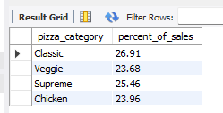

1. Size wise total sales;

select

distinct pizza_size,

round(sum(total_price),0),

round(sum(total_price)/(select sum(total_price) from sales)*100,2) as PCT

from sales

group by pizza_size

order by PCT desc;

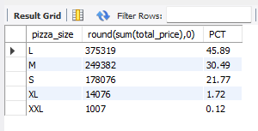

1. 5 best seller

select

pizza_name,

sum(total_price) as Total_Revenue

from sales

group by pizza_name

order by Total_Revenue desc

limit 5;

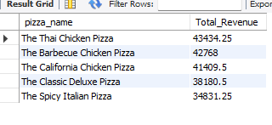

1. 5 least seller

select

pizza_name,

round(sum(total_price),2) as Total_Revenue

from sales

group by pizza_name

order by Total_Revenue asc

limit 5;

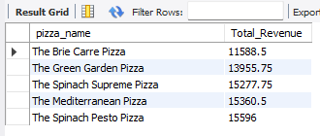

1. Most ordered

select

pizza_name,

round(sum(quantity),2) as Total_Quantity

from sales

group by pizza_name

order by Total_Quantity desc

limit 5;

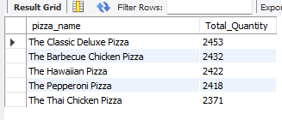

1. Least ordered

select

pizza_name,

round(sum(quantity),2) as Total_Quantity

from sales

group by pizza_name

order by Total_Quantity asc

limit 5;

